Creating a Database File in Microsoft Access 2003

Open Microsoft Access 2003.

Click on File in the menu.

Drag down and select New.

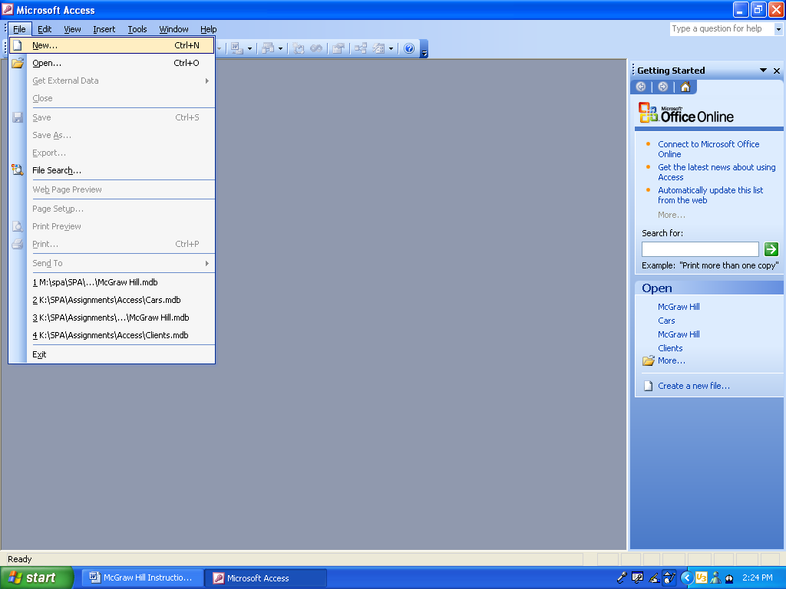
Drag down and Click on New
Click on File in the menu
Look to the right of your screen and find Blank Database. Click on it.

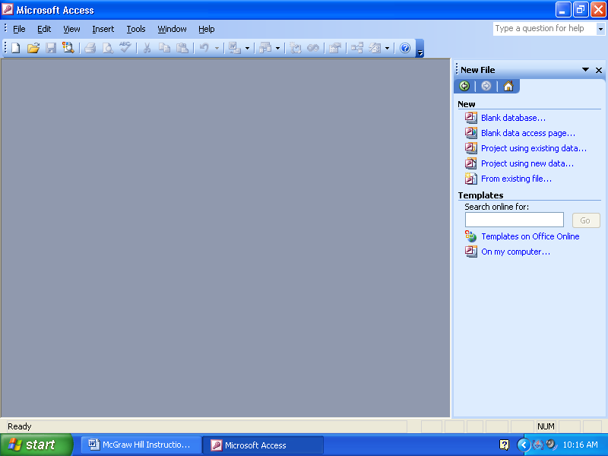
Click on Blank Database
Save with the file name McGraw Hill and press the Create button.

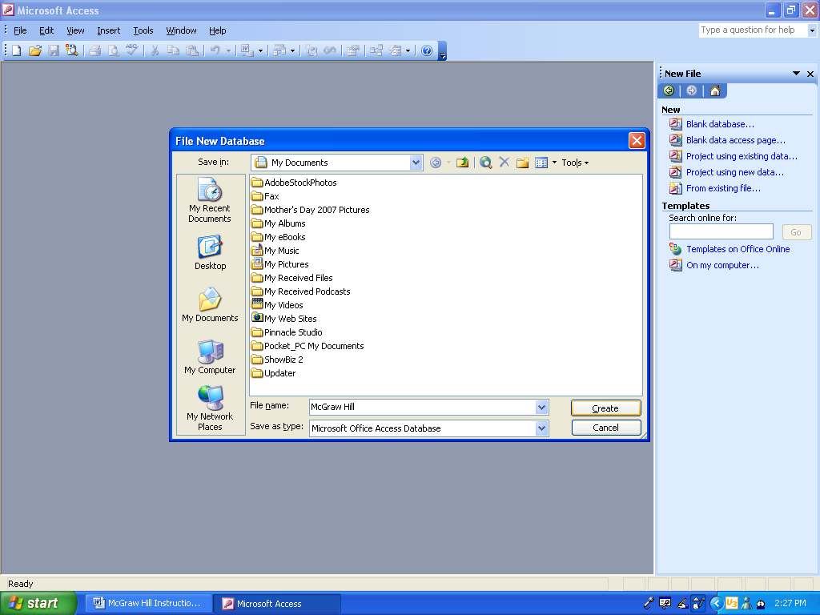
Press the Create button
Type in the name of the file
Click on Table.

Double click on Create table by entering data.
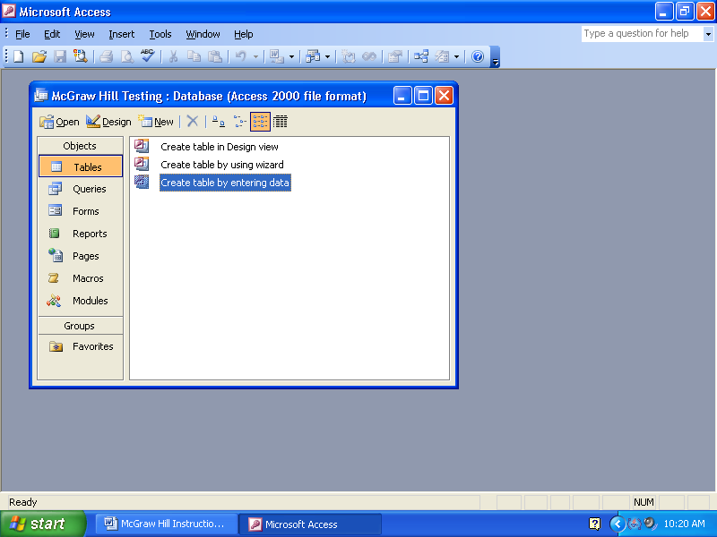
Double click on
Create table by entering data
Click on Table

Double click in Field 1 and type in Publisher.
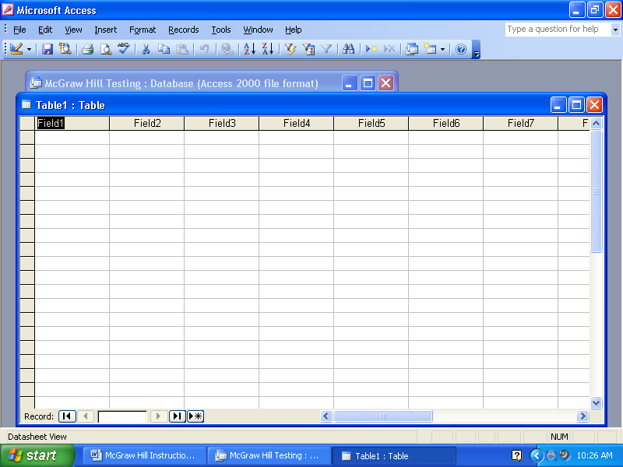
Double click in Field 1 and type in Publisher

Double click in Field 2 and type Author.

Double click in Field 3 and type Title.

Double click in Field 4 and type ISBN Number.

Double click in Field 5 and type Year.

Double click in Field 6 and type List Price. Press the Enter key.

Press the Save icon in the toolbar.

Type in a name for the table and press the Ok button.
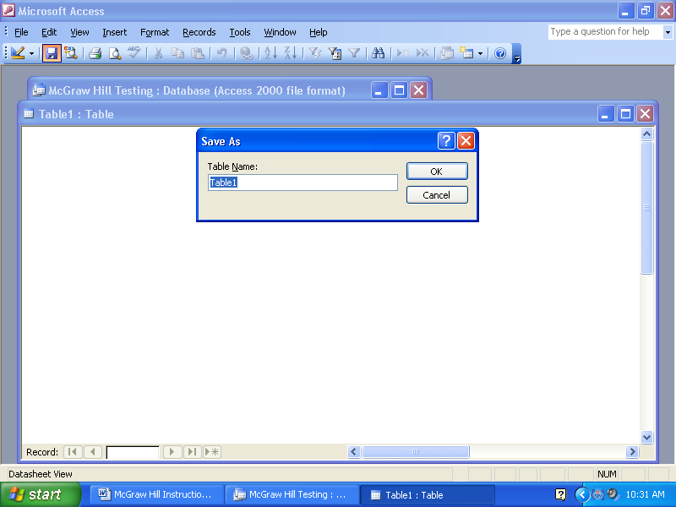
Save
Type in a name for the table
Save button in the toolbar
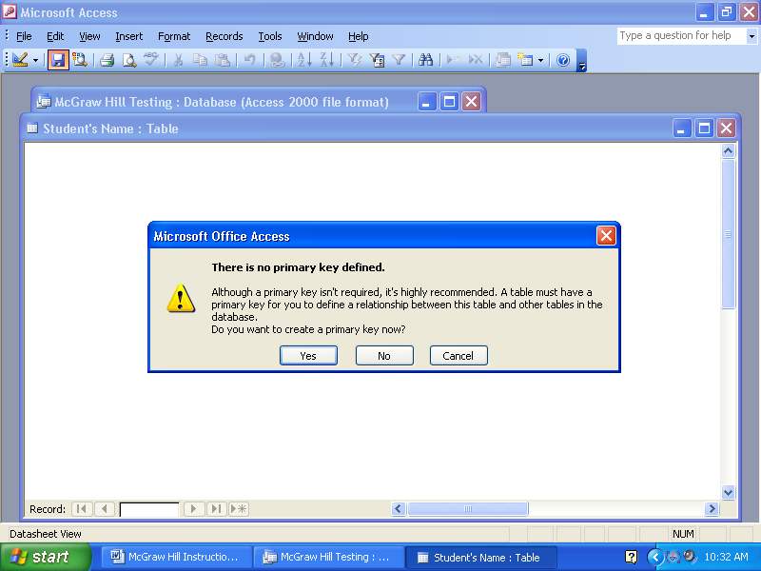
Press the No button if you don’t want a column counting the entries. Press the Yes button if you do want a column counting the entries.
Press No if you don’t want Microsoft Access to create the counter column for you
You have now created a database in which you can type in data.

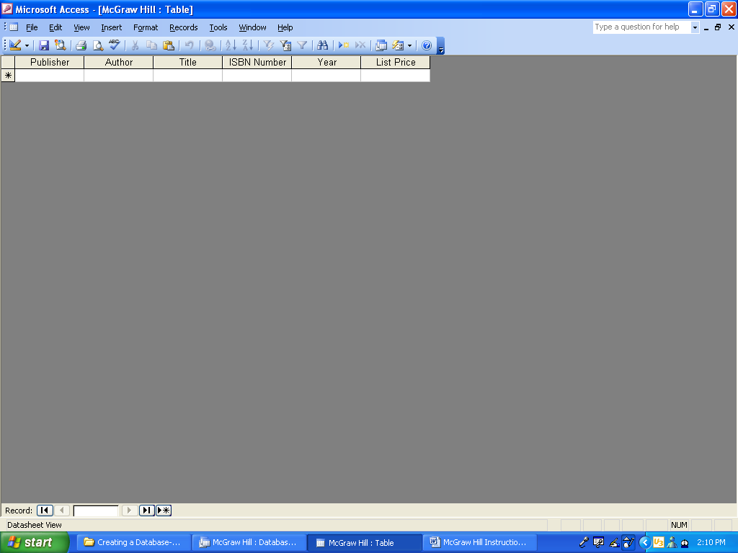

Once you have typed in your data, press the save button in the toolbar.

Once you are ready to print, Access automatically prints in portrait.

To set for Landscape:
Click on File in the menu
Drag down and click on Page Setup

Click on File in the menu

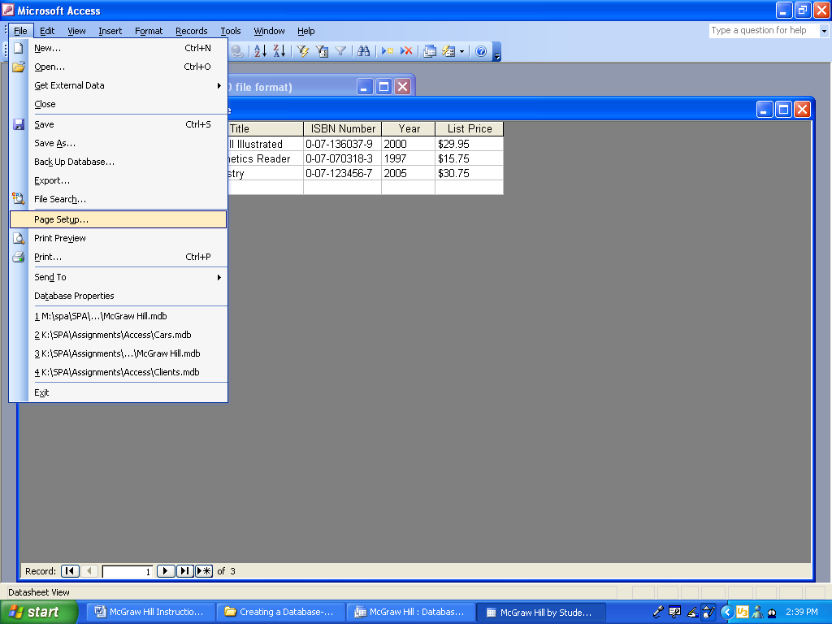
Drag down and click on Page Setup
Click on the Page tab
Click on the Landscape radial button
Press the OK button

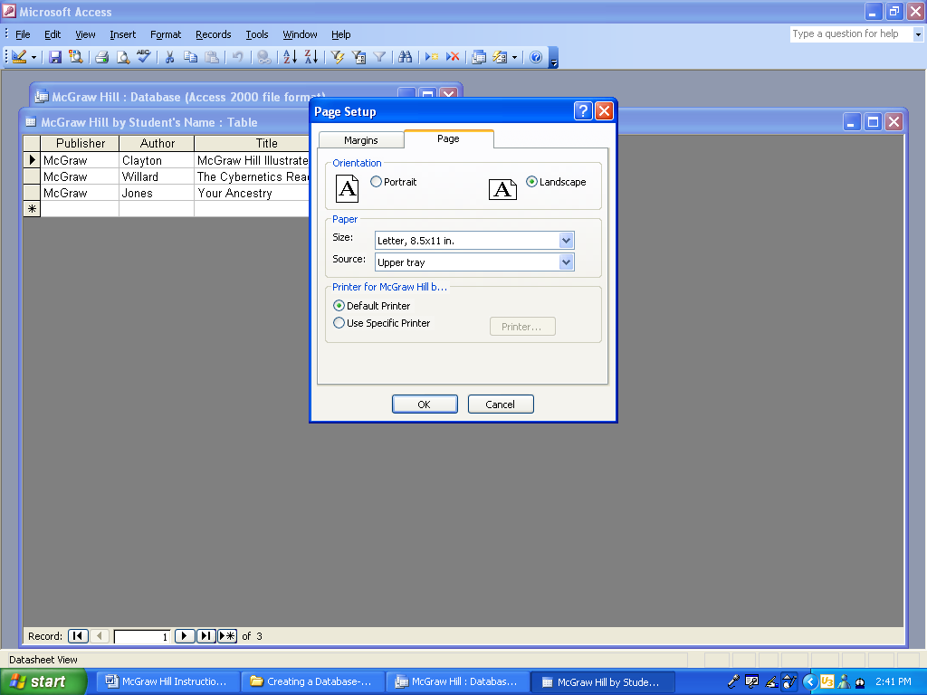
Click on the Page tab
Click on the Landscape radial button
Press the OK button
When you are ready to print, press the Print icon in the toolbar.

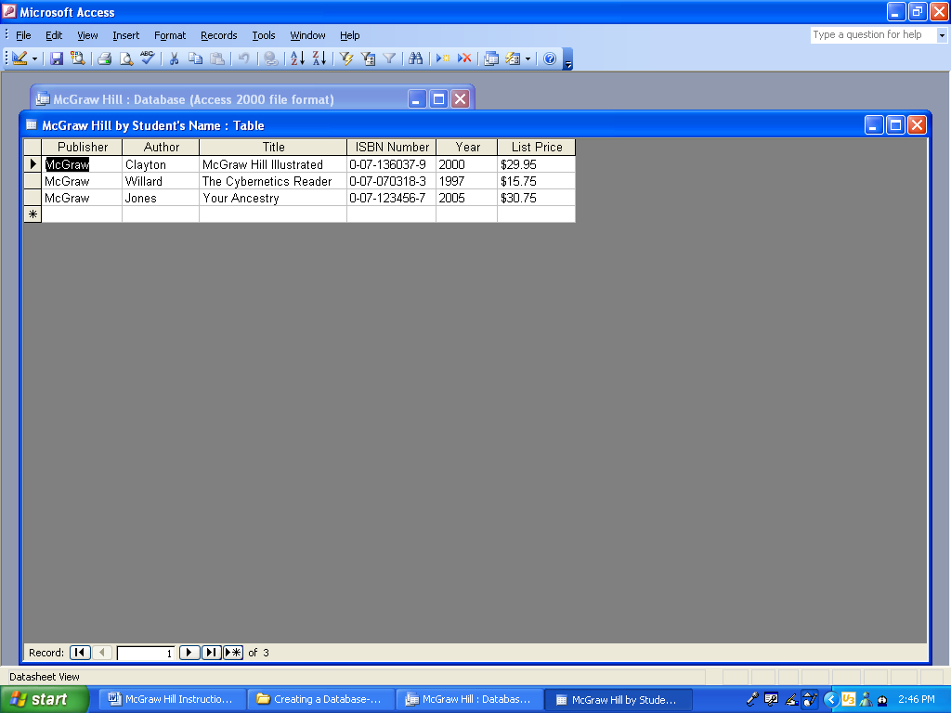
Press the Print icon in the toolbar
Close the table by clicking on the red X.

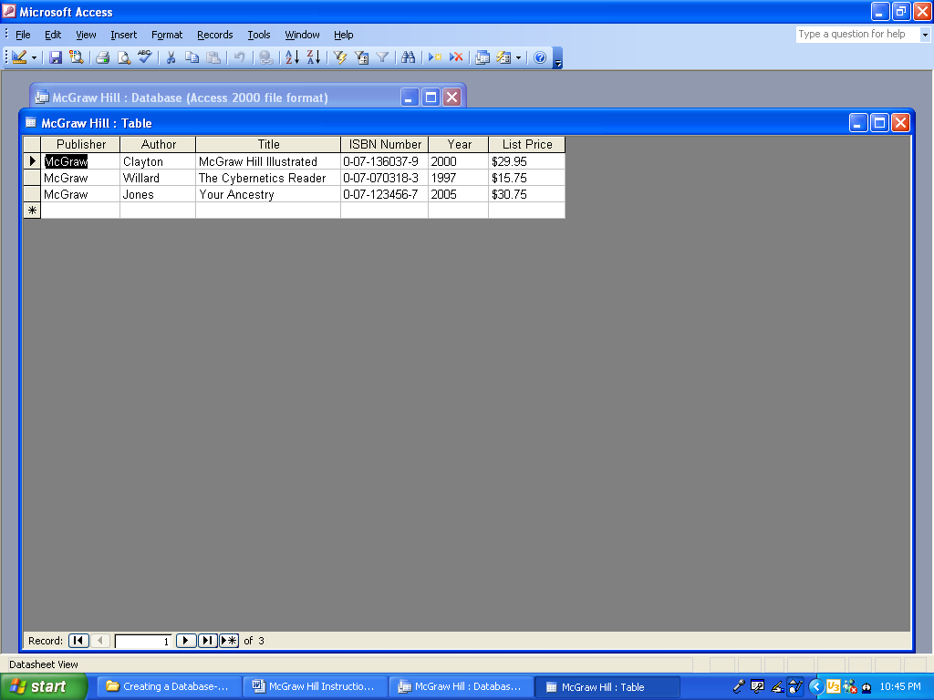
Close the table by clicking on the red X
Notice that you now have a file named McGraw Hill and a table named McGraw Hill.
Press the Printer icon in the toolbar

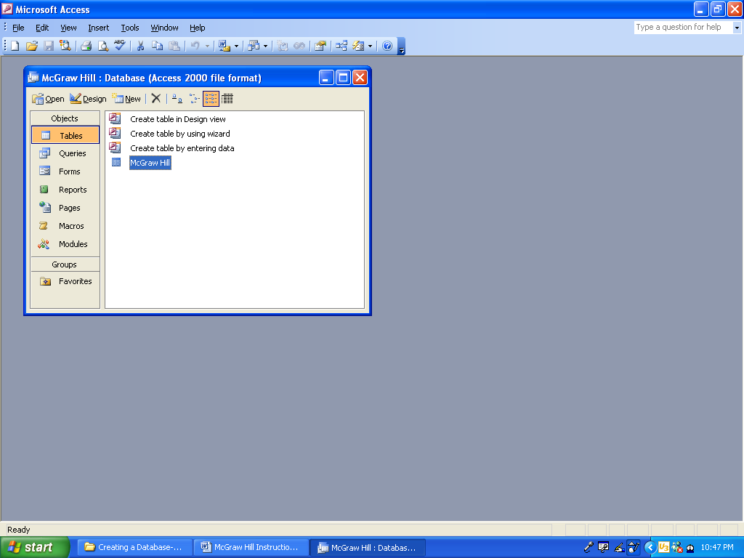

File name is McGraw Hill
Table name is McGraw Hill

To close Microsoft Access, click on the red X.
To close Access, click on the red X
