Creating Queries in Microsoft Access 2003

Open Microsoft Access 2003.

Open the file McGraw Hill.
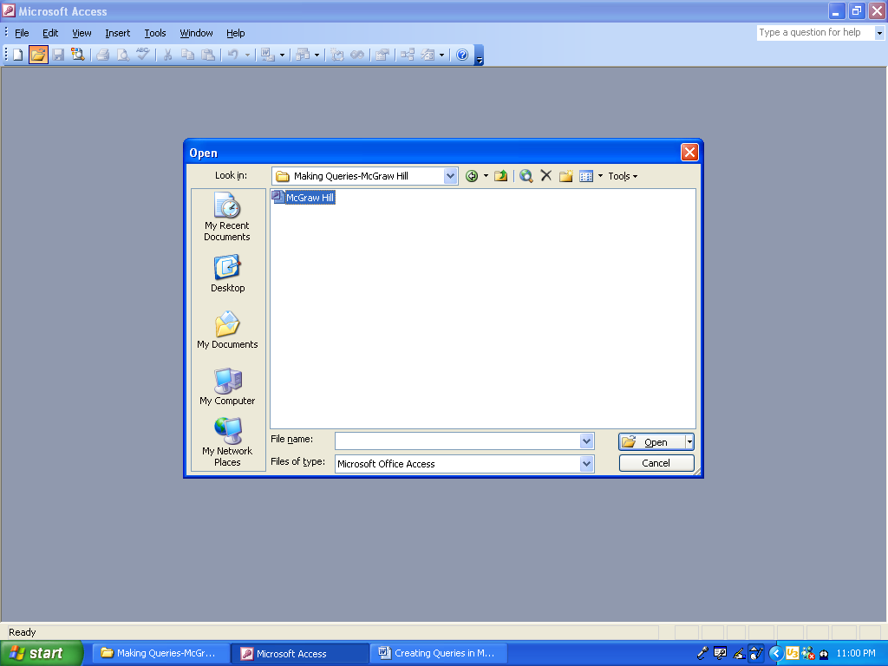

Click on the folder icon
In the Look in box click on the down arrow and locate the file
Click on the file
Press the Open button
Click on the file folder in the toolbar
Click on the file name
Press the Open button

Press the No button.
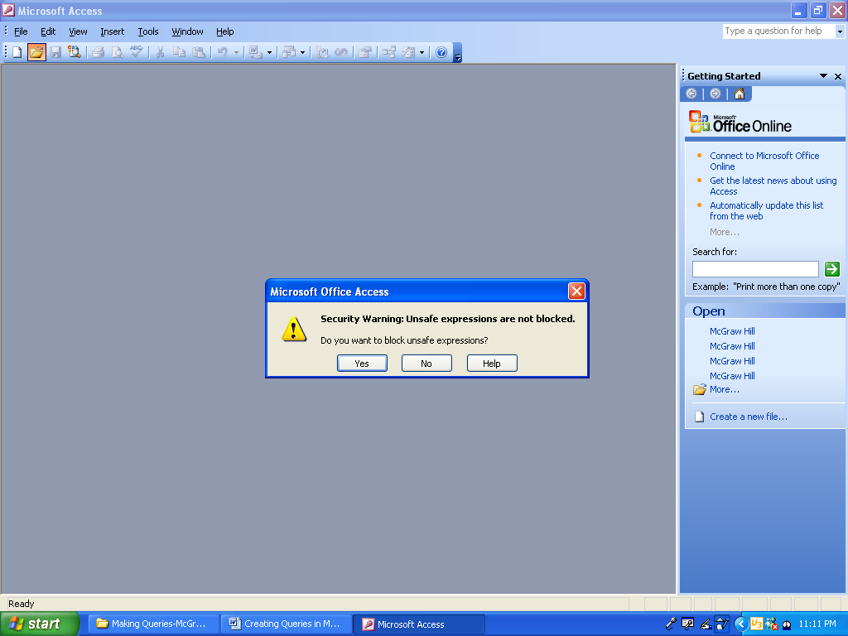
Press the No button
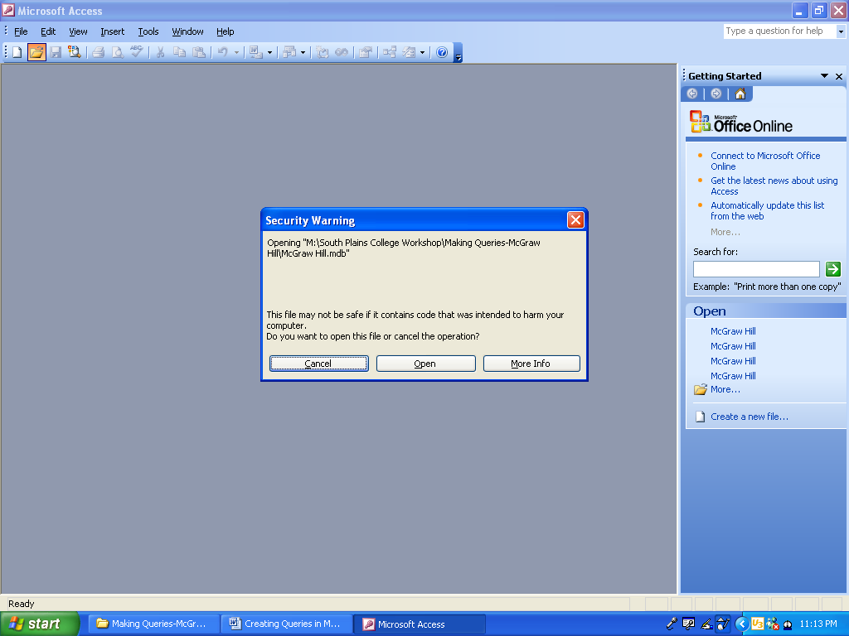
Press the Open button.
Press the Open button
Click on Queries on the left panel.

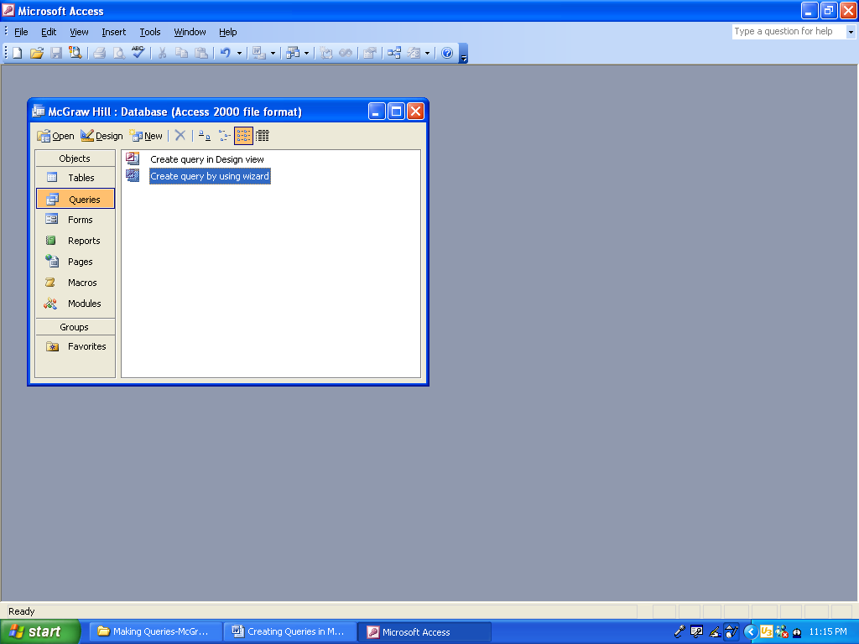
Double click on Create a query by using the wizard.
Click on Queries on the left panel
Double click on Create query by using the wizard
To create a Query such as – Publisher, ISBN Number, List Price:

Move the field headings over from Available Fields to Selected Fields using the >

When through moving field headings over, press the Next button.
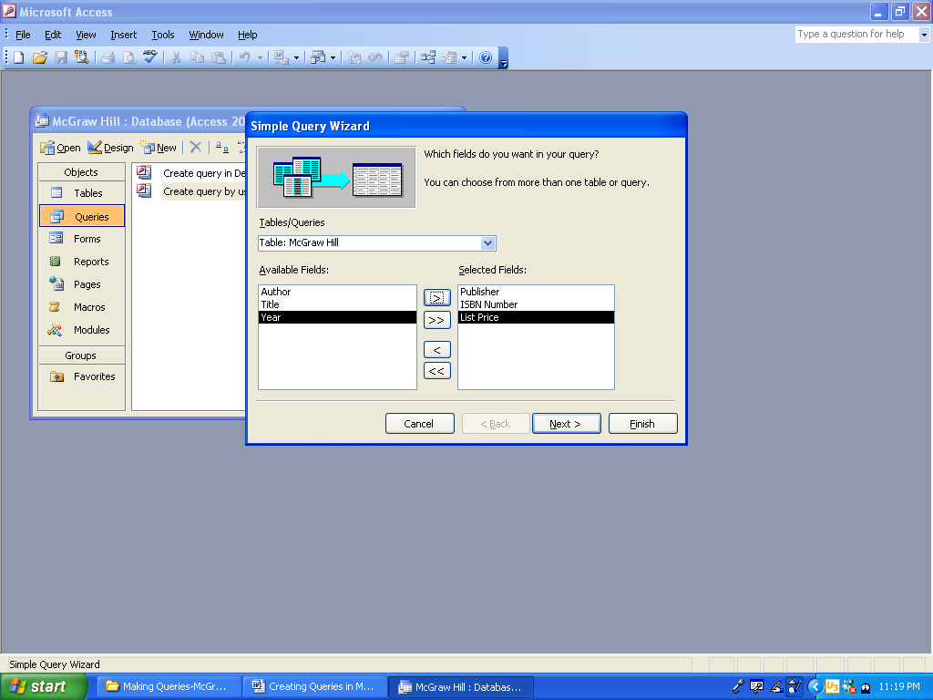

Move from Available Fields
To Selected Fields
Click on to move

Move field headings over from Available Fields
To Selected Fields using the >
>
Press the Next button
Suggestion: Name your query showing the field headings.

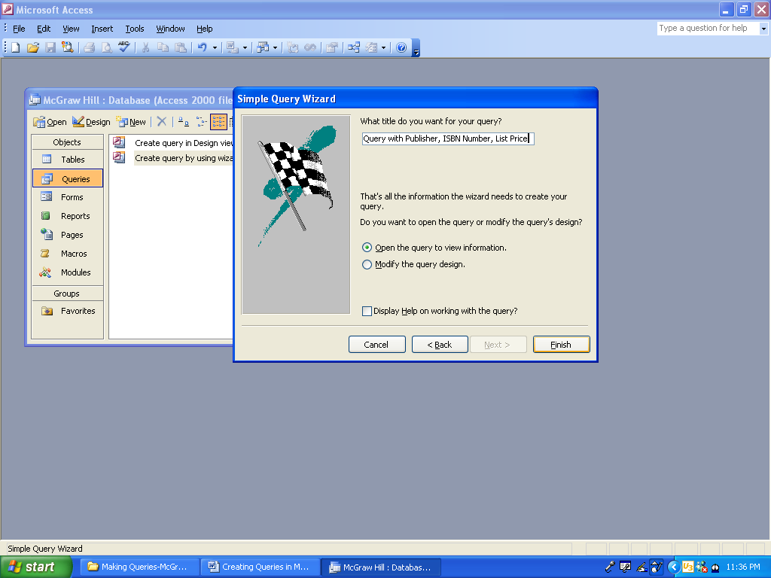
Press the Finish button.
To tell what is in the query, name the query with the field headings
Press the Finish button
Your query will appear.

Press the Print icon in the toolbar.

Close the Query by clicking on the red X.

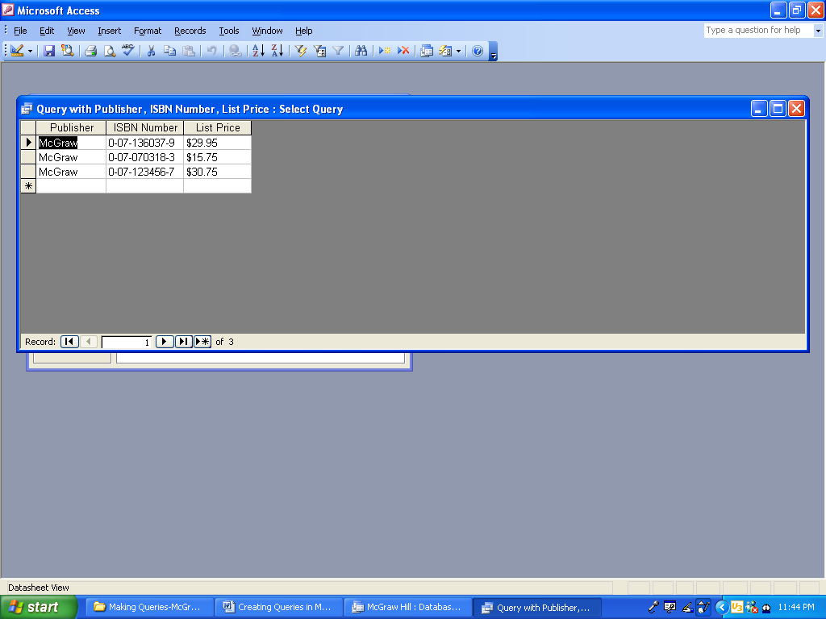
Print icon
Close the Query by clicking on the red X
The Query has a title that tells you what is inside.

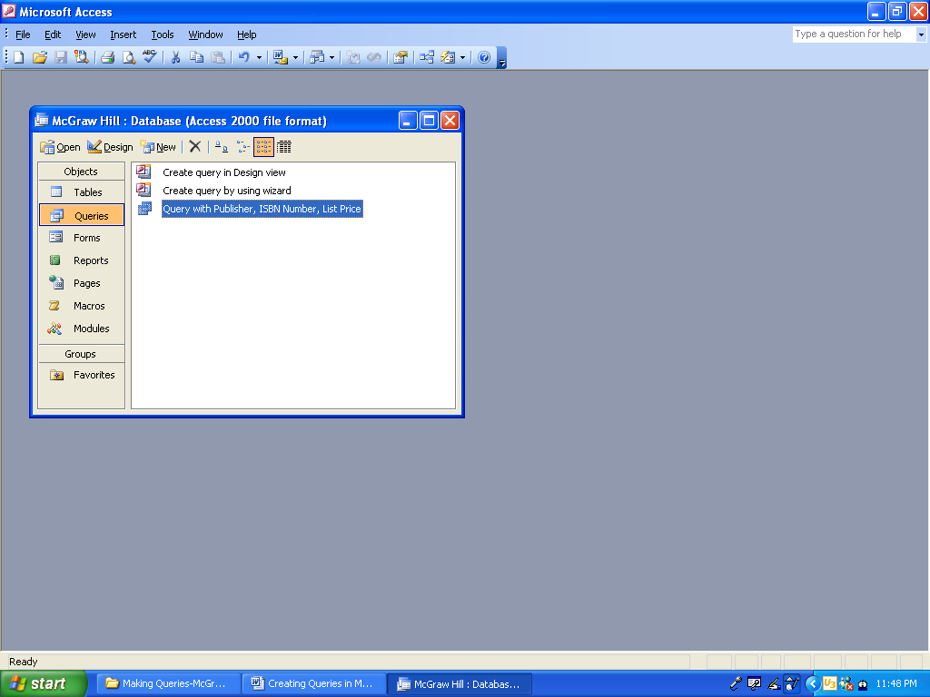
Close Access by clicking on the red X.
Name of Query tells the information inside of the Query
Close Access by clicking on the red X

